

Well the mid-sems have arrived. They are finally here and knocking at your door. That major procrastination event, the Easter long weekend, has been and gone and here we all are. Facing the mid-sems with nought but a single word, and copious highlighting to our name. However, have no fear for the break is soon to be here, and with it a welcome respite from everything that university has to offer.

*Doing it for Bill since 2014*

THE BRUCE BILLITIN

**ISSUE 08: Tuesday 29th March - Sunday 3rd April**

*Doing it for Bill since 2014*

THE MANY WONDERS OF CANBERRA

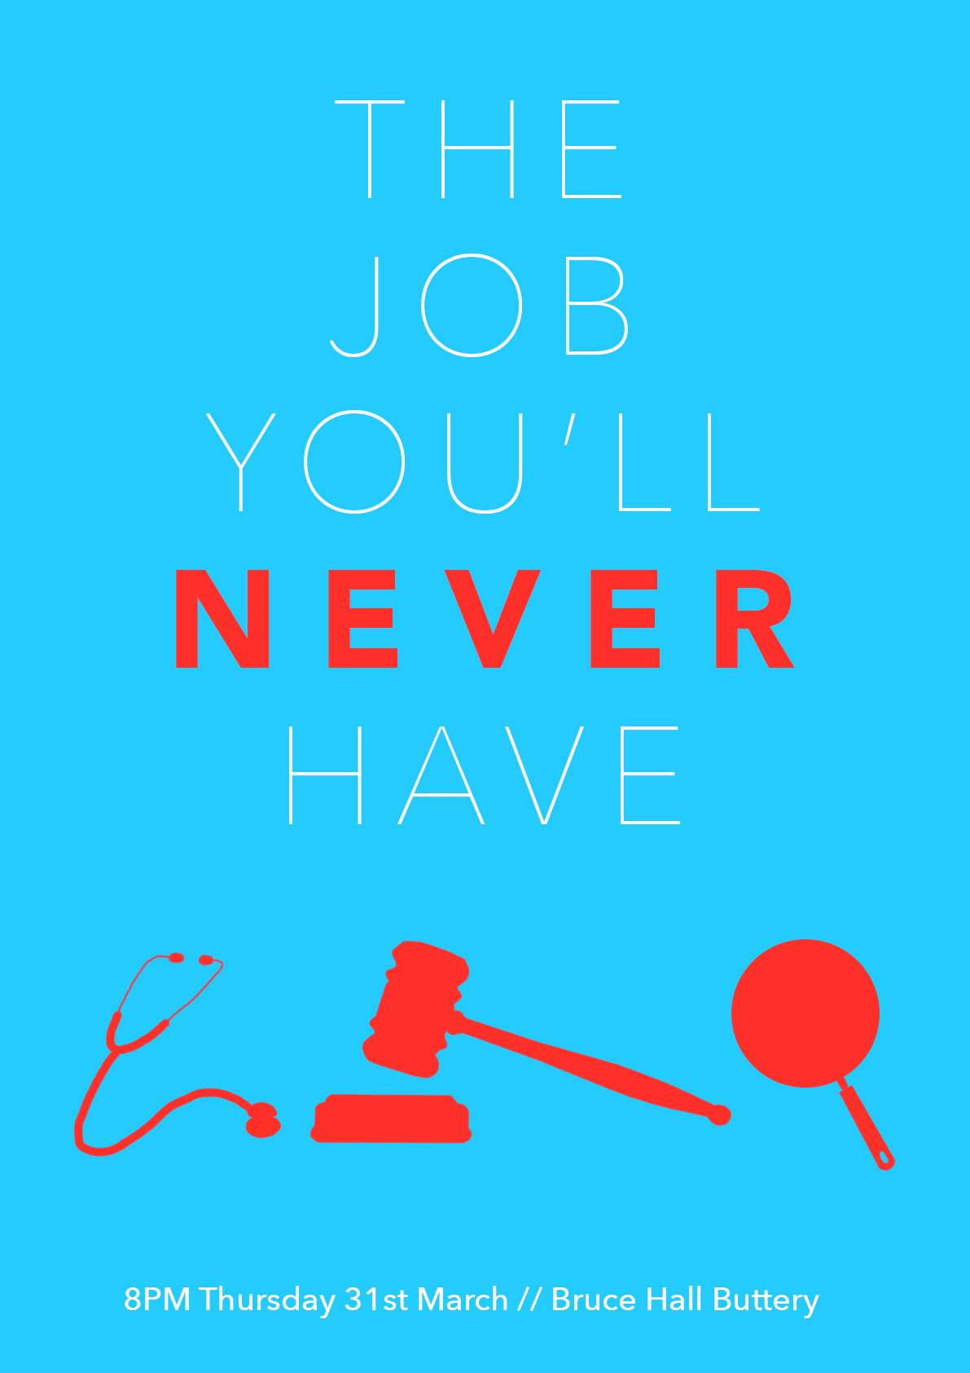

Canberra this week stays true to its theme of having events which no other city in Australia has, for better or for worse.

* **Sunday 3rd April 9:30am-1:30pm at Canberra International airport:** Explore the Canberra airport and its planes, as they do aerobatic displays and are even available for climbing aboard!
* **Canberra Walking Festival 2-3rd April:** Stretching over two days is the 25th Canberra two day walk, which is open to all ages. The routes pass national monuments and head along our costly paths, Head to the website for more info.
* **Auto Italia Canberra 3rd April at Old Parliament House:** An exhibition of Italian Cars, motorbikes and Italian food.

For more info as to events had to: http://visitcanberra.com.au/events/find

BRUCE HALL: An interactive Guide

It’s the last week of term, and with that comes two very big events.

* **WOMEN’S BASKETBALL GRAND FINAL**: WOOOOOOOOH we made it! Congratulations to the women’s basketball team! So that means we all need to head down and support them so grab your Bruce gear and head down to the sports hall at 2:30pm on Thursday the 31st of March.
* **“The Job you’ll never have” Buttery Night:** On Thursday the 31st of March we can celebrate the year so far with a buttery night which we hope you won’t forget! So come as the job you’ll never have, remember those dreams of youth, and party like it’s the end of term 1, because it actually is!

SCHIMDT HAPPENS- What’s on in ANU

* **30th March Art Forum: NAMINAPU MAYMURU WHITE**: A discussion of this incredible artists practise and history in the SOA Lecture Theatre
* **Green Growth and the Emerging institutions 31st March (Public lecture)** :A lecture by Dr Imran Ahmad into the developing world of green growth as an approach to economic growth. Held in the Fenner Seminar Room at 1pm.
* **Photography Workshop with Wei Leng Tay 2nd April**:Join renowned photographer Wei Leng as she helps you construct a story using your own images at 1pm in the School of Art.

For more info and events head to: www.anu.edu.au/events

*‘Vote………..Liberal’*- Bill Shorten



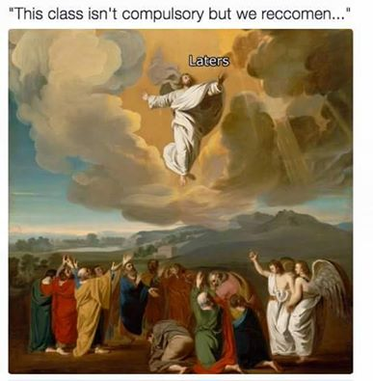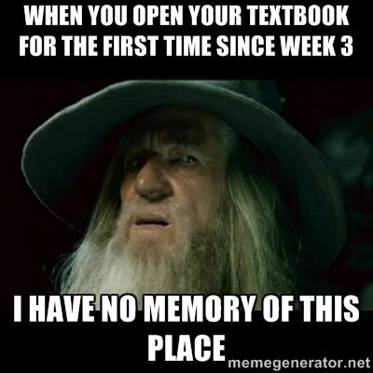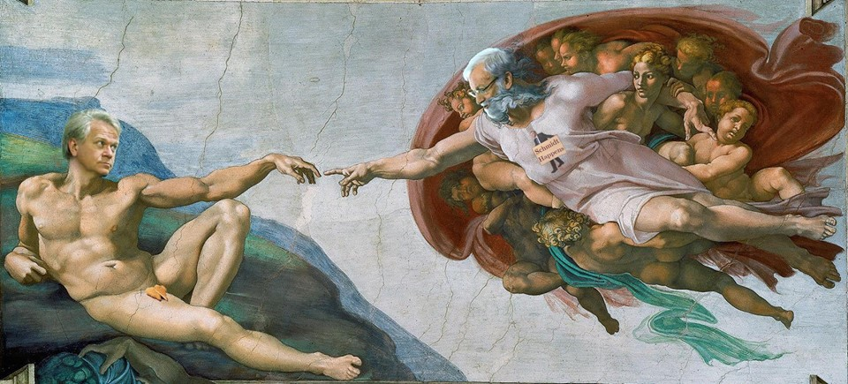

THE DANKEST OF MID-SEM MEMES –   
With ANU Stalkerspace

**With mid-sems comes a barrage of memes on all of   
your innocent facebook walls. Whether you are being  
 raided by the rare pepes, mauled by first world problems girl, or backed up against the wall by caat pics, during Mid-semester exam time, the meme is certainly strong on facebook. So why not bring them to the Billitin, because we’re hip and cool and in tune with you young folk!**





Solid 7/10 Would r8 gr8 m8 for all issues

Gandalf shall always pass my Meme quality test.

A classical meme is always a favourite among the critics and connoisseurs of our fine internet community

1. Liechtenstein, 2. 2004, 3. 1606 (1600’s), 4. India, 5. FORTRAN, 6. The Shepherd’s Crown, 7. Phnom Penh, 8. Yarralumla Turkish Halal Pide House, 9. North Korea, 10. The Rolling Stones

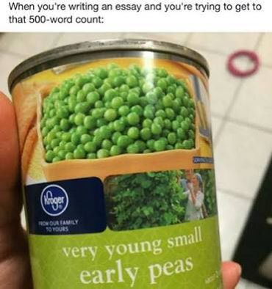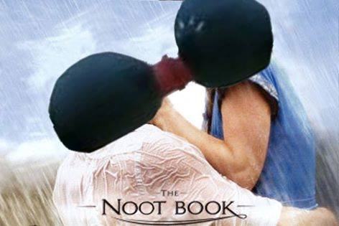

TRIVIA

1. What is the world’s leading manufacturer of false teeth? 6. What was the name of Terry Pratchett’s last novel?

2. The Notebook was released in what year? 7. What is the capital of Cambodia?

3. In what decade did European explorers first visit Australia? 8. What is currently the top ranked (according to tripadvisor)

4. Who knocked Australia out of the twenty 20 cricket world cup kebab place in Canberra?  
 in 2016? 9. Which country has the largest sports stadium in the world?

5. What was the first widely used high level general purpose 10. Which famous rock band recently played a concert in   
 functional programming language to be invented? Cuba?

Not at all a technique I use in my very long wordy showstopping 2000 word essays

While some may argue this has no relation to exams, I beg to differ. I love making noots when I am studying as opposed to notes.